Cairo University Faculty of Computers and Information



**Software Engineering II**

**Software design specification document**

**2020**

**Project Team**

|  |  |  |  |
| --- | --- | --- | --- |
| **ID** | **Name** | **Email** | **Mobile** |
| 20170022 | Ahmed Sayed Mansour | ahmed.mans20719@gmail.com | 01117908189 |
| 20170002 | Ibrahim Ramadan Abdou | Ibrahemramadan130@gmail.com | 01152395815 |
| 20170257 | Mohamed Mostafa | mmostafaouda@gmail.com | 01122331195 |
| 20170136 | Atef Magdy Mitwally | Atefmagdy12@gmail.com | 01120797140 |
|  |  |  |  |
|  |  |  |  |

**TA. Basma Moukhtar**

Contents

Class diagram design 2

Sequence diagram design 3

Github repository link 4

# Class diagram design

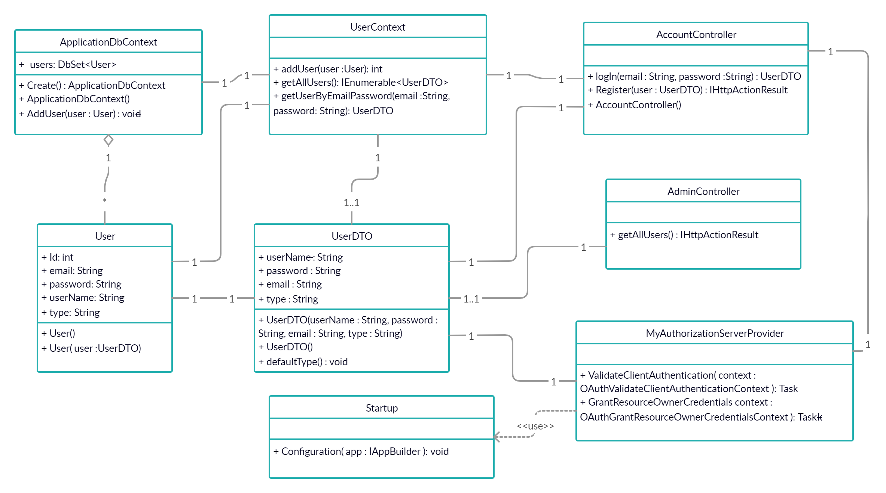

# 

# Sequence diagram design

1-Register

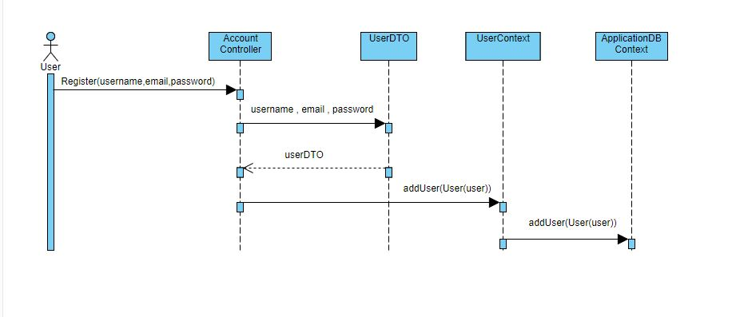

2-Login

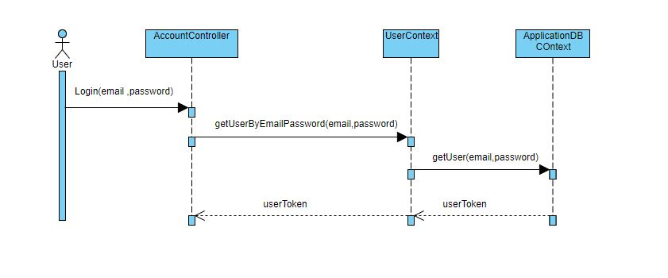

3-getAllUsers

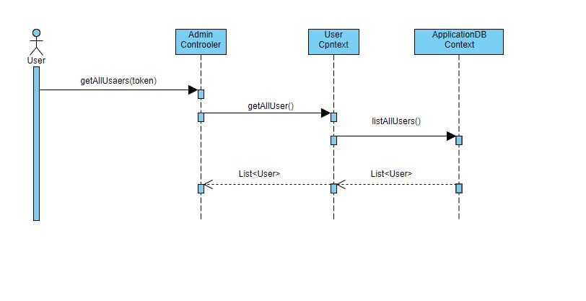

# GitHub repository link

* https://github.com/AhmedSayedMansour/Online-Store-Platform-API